**scp filename username@ip:/directory**

**How to connect to ec2 without PEM?**

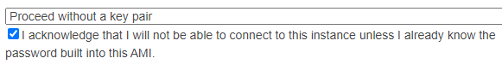

**How to recover pem file?**

#Stop server-without-keys and detach the root volume

# Start another server which has keys and ensure they run the same operating system as previous server, say RedHat Linux

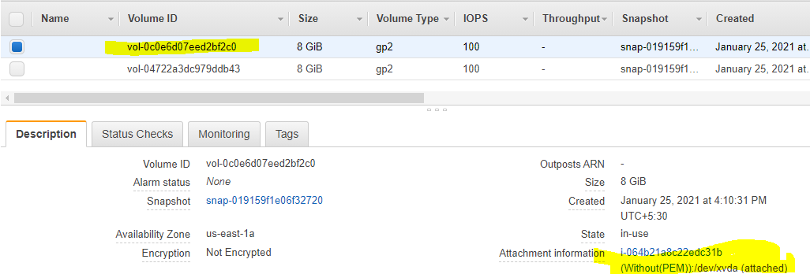

# Attach the 'server-without-keys' root volume to this server

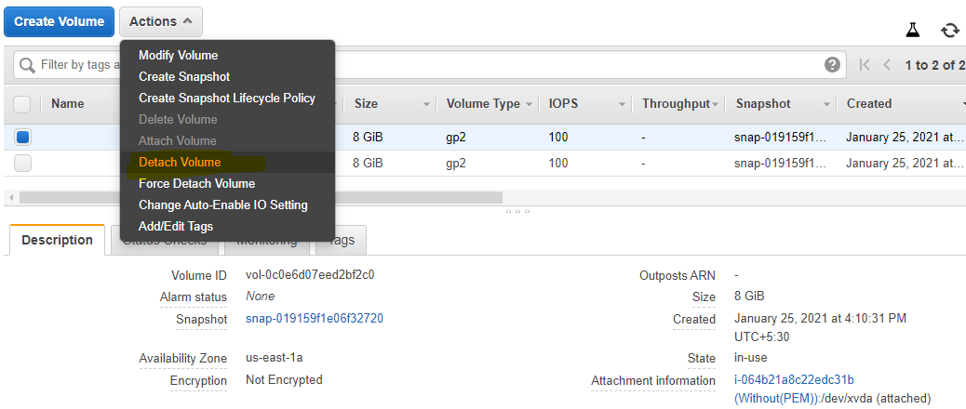

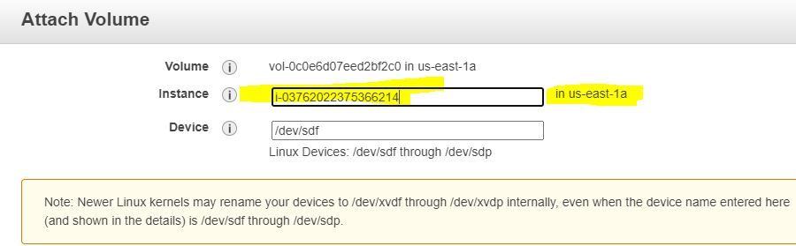

#lsblk--lsblk lists information about all available or the specified block devices

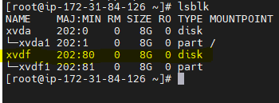

# Create the Mount Point

**mkdir -p /var/recovery-disk**

# Mount the disk

mount -o nouuid /dev/xvdf2 /var/recovery-disk

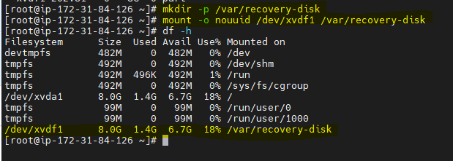

# Copy over the authorized keys

cp /home/ec2-user/.ssh/authorized_keys /var/recovery-disk/home/ec2-user/.ssh/authorized_keys

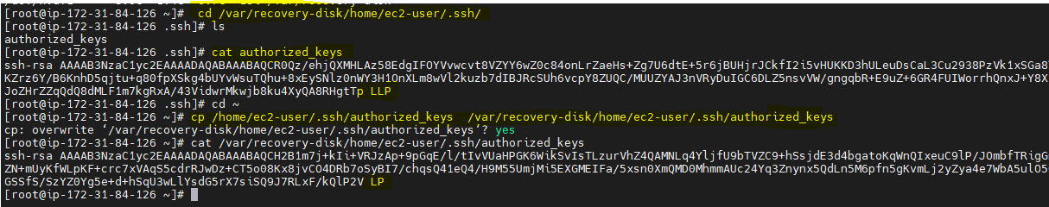

# Unmount the disk

umount /var/recovery-disk

# Attach from AWS GUI Console to server as root disk. For example: /dev/sda

# Connect with Keys [RecoveryServer Key]

**How to save logs from Ec2 to S3 bucket?**

**How to do data migration from on-prem to S3?**

**Can we store artifacts on ECR?**

**What Is inline policy In IAM?**

**A customer wants to deploy his application on cloud how do you suggest?**

Firstly will ask type of application and is it 3 tier or a 2 tier and then will explain him about the AWS services,

1. We’ve EC2 for computing so what type of instances and classes ,purchase option you recommend and size of memory,cpu ,EBS want to use and also if you want we can expand the size in future.Termination protection,directory services.
2. Security groups and NACL,Key-pair.
3. Your instance and application inside it will be safer ,with virtual private cloud,and for HA and we can deploy the application instance on diff AZ
4. Frontend app will put on public subnet,,database on private.
5. And will store all the log files and data related to app on s3 by providing IAM role access.
6. And also there will be Auto scaling and Load balancer features.(SSL ,ACM)
7. And we’ve cloud watch facility ,so that we can monitor every instances and applications.
8. Route53

**What is trust relationship in IAM?**

With IAM roles, you can establish trust relationships between your trusting account and other AWS trusted accounts. The trusting account owns the resource to be accessed and the trusted account contains the users who need access to the resource.

**Can we move Ec2 instance from one VPC to other?**

Directly it is not possible,,if u want create an AMI of the ec2 and create an Ec2 on that VPC.

**Does private IP change in AWS?**

An instance's private IP address will never change during the lifetime of that instance.

**If we stop an instance will public and private IP’s will remain same?**

No public IP will change and private IP will remain

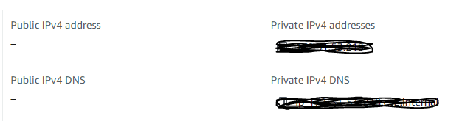

**Will Public and Private Ip’s remain same if we reboot the instance?**

Yes public and Private IP’s will not change if we reboot the instance.

**Why can’t we call EIP as a permanent IP?**

We can associate and disassociate to any instances,so its not permanent to any instances.

**How to save logs/data from Ec2 to S3 bucket?—**Using AWS CLI (S3 cp)

**How to change/upgrade Ec2 instance type?**

1) Shutdown the instance

2) Instance settings—change instance type

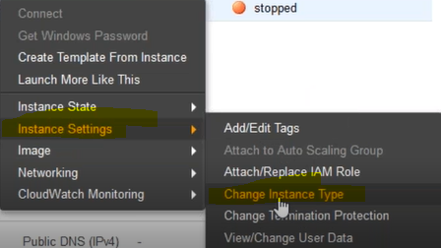

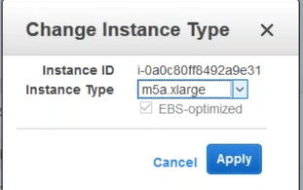

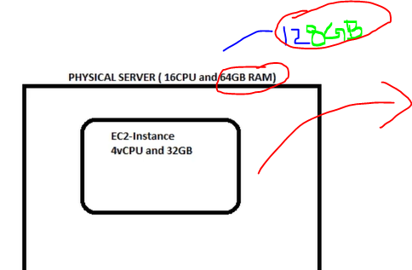

**Lets say if I want to access/download an object/file from on ec2 instance which is in private subnet from S3 bucket ,is it possible ,if Yes how?**

Yes it is possible if we create an VPC endpoint

**How ELB and autoscaling are related?**

When you use Elastic Load Balancing with your Auto Scaling group, it's not necessary to register your EC2 instances with the load balancer. Instances that are launched by your Auto Scaling group are automatically registered with the load balancer. Likewise, instances that are terminated by your Auto Scaling group are automatically deregistered from the load balancer.

After attaching a load balancer to your Auto Scaling group, you can configure your Auto Scaling group to use Elastic Load Balancing metrics such as the request count per target (or other metrics) to scale the number of instances in the group as the demand on your instances changes.

**Can we monitor instance without cloud watch ?---** Manage Detailed monitoring

**What is access point in S3?**

Access points are named network endpoints that are attached to buckets that you can use to perform S3 object operations, such as GetObject and PutObject.

**Is S3 support VPC? ---**(S3 Doesn’t support VPC)

**Types of IAM policy?**

1. **Identity-based policies:**The identity-based policy is the one that can be attached directly with AWS identities like user, group or a role. IAM policy is an example of that. These policies can be AWS managed or a customer-managed.
2. **Resource-based policies:** Resource-based policies are the ones which can be directly attached to the AWS resource like S3( called Amazon S3 bucket policy). Resource-based policies are available only for certain services.

**How others can access objects in s3 bucket?**

Users can access the objects in the bucket ,if we provide the access using bucket policy.

Ex ::

{

"Version":"2012-10-17",

"Statement":[

{

"Sid":"PublicRead",

"Effect":"Allow",

"Principal": "*",

"Action":["s3:GetObject","s3:GetObjectVersion"],

"Resource":["arn:aws:s3:::*DOC-EXAMPLE-BUCKET*/*"]

}

]

}

<https://docs.aws.amazon.com/AmazonS3/latest/dev/example-bucket-policies.html>

**Lets say I have 50 users ,for all 50 users I need to provide same privileges how to do?**

Create group and add all users to that group and assign the policy.

**I want to give programmatic access means so that user can access AWS services via API’s?How to create ?**

Create an user ,while creating select programmatic access ,then u’ll get a access key and secret key.Using which user can access AWS services through CLI,API

**I have a Ec2 machine in that I have installed many applications,now I need to create another machine with the same configuration.Is it possible in AWS?If yes how to do ?**

Create an AMI from the Ec2 volume ,and launch instances as many as you want using the same.

**As AMI is region specific, I want to create a machine with AMI which is there is another region?Is it possible?**

Create an AMI ,select the option copy image and select the region (U can also encrypt the same)

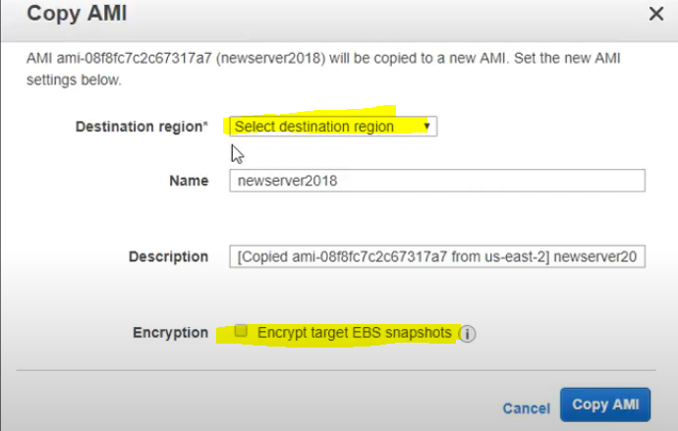

**Why we need security group? By default what is outbound rules?**

Security groups are assigned to instances it acts as a firewall ,by default outbound is opened.

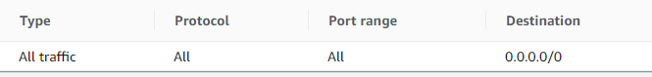

**Lets say I have created auto scaling group ,whenever load goes more than 60% it scale out new instance.Currently I have 3 machines ,1st machine load is 62% ,2nd 30% ,and 3rd 30%. Now will the auto scaling group creates new instance?**

No,bcz it takes the avg 62%+30%+30%

**What is cloud computing. what are the advantages compare to on-premises?**

Cloud computing is the delivery of different services through the Internet.

*Maintenance and services are handled by cloud providers.

**How to configure Autoscaling and what is the main indication to use autoscaling?**

Configure launch configuration according to your requirement.(AMI ID,security group.instance type,key pair etc)

Put the conditions in auto scaling group ,when to trigger. Like cpu,memory,network..etc.(VPC ,subnet and other details)

**Though my Ec2 instance is in stopped state , I’m getting charged. what may be the reason?**

Because of the root EBS volume attached to the instance.

**How to configure security in Aws environment?**

With security group/NACL rules and with https

**Can you explain types of instance?**

* + [**General Purpose**](https://cloudacademy.com/blog/aws-ec2-instance-types-explained/#general): The most popular; used for web servers, development environments, etc.
  + [**Compute Optimized**](https://cloudacademy.com/blog/aws-ec2-instance-types-explained/#compute): Good for compute-intensive applications such as some scientific modeling or high-performance web servers.
  + [**Memory Optimized**](https://cloudacademy.com/blog/aws-ec2-instance-types-explained/#memory): Used for anything that needs memory-intensive applications, such as real-time big data analytics, or running Hadoop or Spark.
  + [**Accelerated Computing**](https://cloudacademy.com/blog/aws-ec2-instance-types-explained/#accelerated): Include additional hardware (GPUs, FPGAs) to provide massive amounts of parallel processing for tasks such as graphics processing.
  + [**Storage Optimized**](https://cloudacademy.com/blog/aws-ec2-instance-types-explained/#storage): Ideal for tasks that require huge amounts of storage, specifically with sequential read-writes, such as log processing.

**Types of vpc's?**

* Amazon VPC with a single public subnet only.
* Amazon VPC with public and private subnets.
* Amazon VPC with public and private subnets and AWS Site-to-Site VPN access.
* Amazon VPC with a private subnet only and AWS Site-to-Site VPN access.

**Can we detach root volume of an instance?**

Yes ,but instance should be in stopped state

**Can you differentiate scalability and elasticity?**

Scalability is the ability of the system to accommodate larger loads just by adding resources either making hardware stronger (scale up) or adding additional nodes (scale out).

Elasticity is the ability to fit the resources needed to cope with loads dynamically usually in relation to scale out

**what is listener in ELB?---** A listener is a process that checks for connection requests

**what is multifactor authentication?**

AWS Multi-Factor Authentication (MFA) is a simple best practice that adds an extra layer of protection on top of your user name and password.

**can we mount s3 bucket to ec2 machine? and why it is not recommended?**

We can mount an S3 bucket onto an AWS instance as a file system known as **S3fs**. It is a FUSE filesystem application backed by amazon web services, that allows you to mount an Amazon S3 bucket as a local file-system.

**can we move custom AMI from one account to different account?—**yes

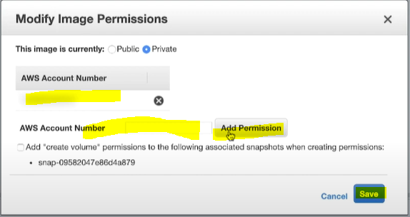

**what is the diff b/w ebs and s3?**

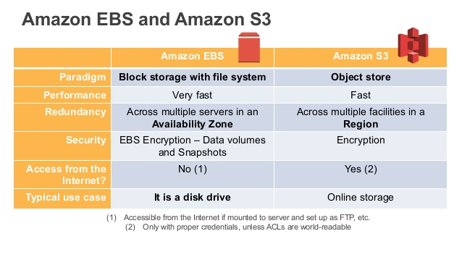

**Can we edit files in s3?**

you can't edit s3 files directly in s3. But you can sync your bucket locally and upload your changes to the s3 bucket.

**AWS S3 how others can access s3 bucket?----**By creating a bucket policy

**What is the default security behaviour for EBS?**

For simplified data encryption, you can create encrypted EBS volumes with the Amazon EBS encryption feature. All EBS volume types support encryption. You can use encrypted EBS volumes to meet a wide range of data-at-rest encryption requirements for regulated/audited data and applications. Amazon EBS encryption uses 256-bit Advanced Encryption Standard algorithms (AES-256) and an Amazon-managed key infrastructure.

**Records in Route53 ?**

* A (address record)
* AAAA (IPv6 address record)
* CNAME (canonical name record)
* CAA (certification authority authorization)
* MX (mail exchange record)
* NAPTR (name authority pointer record)
* NS (name server record)
* PTR (pointer record)

**Types of volumes in AWS?---** EBS,EFS,FSX,S3 etc

**What is route table?**

A route table contains a set of rules, called routes, that are used to determine where network traffic from your subnet or gateway is directed

**what is site-site VPN ?**

AWS Site-to-Site VPN enables you to securely connect your on-premises network to your Amazon Virtual Private Cloud (Amazon VPC). AWS Client VPN enables you to securely connect users to AWS or on-premises networks.

**What is VPC peering & its advantages?**

A VPC peering connection is a networking connection between two VPCs which are using diff n/w’s that enables you to route traffic between them using private IPv4 addresses or IPv6 addresses. Instances in either VPC can communicate with each other as if they are within the same network.

**Is IAM global or region specific?---**Its gloabal

**How to increase volume in ec2?**(modify volume)—reboot

**want to increase root volume space how you will do that?**

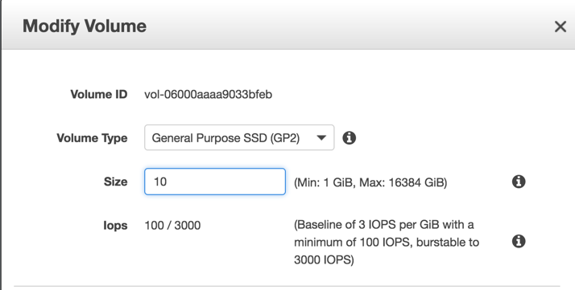

**Whether ELB or ASG will get to know instance failure?--ELB**

**What is TCP and UDP?**

As we know that both TCP (Transmission Control Protocol) and UDP (User Datagram Protocol) are the most widely used Internet protocols among which TCP is connection oriented − once a connection is established, data can be sent bidirectional. UDP is a simpler, connectionless Internet protocol

**Can we take snapshot of instance ,volume?--yes**

**How many EIP we can create**?---- You're limited to five Elastic IP addresses

**Can we block particular IP through Security group?--yes**

**Can we attach IAM role to running instance?--yes**

**Can we chage security group for running instance?=---yes**